Title Page

# DATAANALYSISUSINGSQL–HRINSIGHTS

**Objective**

Theprimarygoalofthisprojectistoconductacomprehensiveanalysisofhuman resources data to gain valuable insights into employee information, recruitment trends, training and development, and employee engagement. The objective is to provide data-driven recommendations and improve HR processes and decision- making.

# Methodology

In the scope of this data analysis project, a series of meticulously planned steps employingSQLtoextractvaluableinsightsfromthedatasetisexecuted.Theproject involvesstagessuchasdatacollection,datacleaningandpreprocessing,exploratory data analysis, querying the database using SQL, aggregating and transforming data, and ultimately deriving meaningful conclusions supported by the data-driven findings.

# DatasetOverviewandData Processing

Theprovideddatasetconsistsofvariousattributesrelatedtoemployeeinformation, recruitment details, training records, and employee engagement survey scores. To ensure the reliability and accuracy of subsequent analyses, comprehensive data preprocessing is conducted. This involves tasks like handling missing values, removingduplicates,andstandardizingdataformatsacrosstables,ensuringthatthe data is consistent and ready for meaningful analysis.

# InsightsandFindings

Various SQLqueries are employed to execute the HR data analysis with efficiency. Thesequeriesincludeaggregatingemployeeinformation,calculatingkeyHRmetrics, categorizing data by different attributes, assess recruitment effectiveness, and understand engagement levels over time. Furthermore, these queries can aid in uncovering insights like the most common reasons for termination and patterns in employee demographics, helping HR professionals make informed decisions about workforce management and engagement strategies.

# KeyStepsPerformedusingSSMS

|  |  |
| --- | --- |
| **training_and_development_data** | |
|  | Employee_ID |
|  | Training_Date |
|  | Training_Program_Name |
|  | Training_Type |
|  | Training_Outcome |
|  | Location |
|  | Trainer |
|  | Training_Duration_Days |
|  | Training_Cost |
|  | |

1. DataRetrieval:UsedSELECTstatementstoextractrelevantdatafromtheHR tables.
2. DataFiltering:UsedWHEREclausetofilterdatabasedonspecificcriteria, such as employee status or training type.
3. DataTransformation:EmployedlogicaloperatorslikeAND,OR,andNOT for more advanced data manipulation.
4. DataSorting:UtilizedtheORDERBYclausetosortqueryresults,facilitating the identification of patterns or priorities.
5. DataIntegration:UsedJOINStocombinedatafrommultipletablesfor comprehensive analysis.
6. DataAggregation:UsedGROUPBYstatementstoaggregatedata,calculate metrics, and create reports for further analysis.

# Entity-RelationshipDiagram

AnEntity-RelationshipDiagram(ERD)iscreatedforthisHRdatasettovisually represent the structure and relationships between the various tables.

|  |  |
| --- | --- |
| **employee_data** | |
|  | Employee_ID |
|  | FirstName |
|  | LastName |
|  | StartDate |
|  | ExitDate |
|  | Title |
|  | Supervisor |
|  | ADEmail |
|  | BusinessUnit |
|  | EmployeeStatus |
|  | EmployeeType |
|  | PayZone |
|  | EmployeeClassificationType |
|  | TerminationType |
|  | TerminationDescription |
|  | DepartmentType |
|  | Division |
|  | DOB |
|  | State |
|  | JobFunctionDescription |
|  | GenderCode |
|  | LocationCode |
|  | RaceDesc |
|  | MaritalDesc |
|  | Performance_Score |
|  | Current_Employee_Rating |
|  | |

|  |  |
| --- | --- |
| **employee_engagement_survey_data** | |
|  | Employee_ID |
|  | Survey_Date |
|  | Engagement_Score |
|  | Satisfaction_Score |
|  | Work_Life_Balance_Score |
|  | |

|  |  |
| --- | --- |
| **recruitment_data** | |
|  | Applicant_ID |
|  | Application_Date |
|  | First_Name |
|  | Last_Name |
|  | Gender |
|  | Date_of_Birth |
|  | Phone_Number |
|  | Email |
|  | Address |
|  | City |
|  | State |
|  | Zip_Code |
|  | Country |
|  | Education_Level |
|  | Years_of_Experience |
|  | Desired_Salary |
|  | Job_Title |
|  | Status |
|  | |

# PERFORMEDQUERIES

1. **CountofEmployeesbyBusinessUnit**

SELECTBusinessUnit,COUNT(*)ASEmployeeCountFROM employee_data

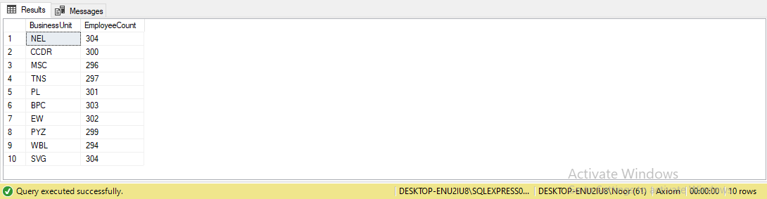GROUPBYBusinessUnit

# CountofEmployeesbyRaceandMaritalStatus

SELECTRaceDesc,MaritalDesc,COUNT(*)ASEmployeeCountFROM employee_data

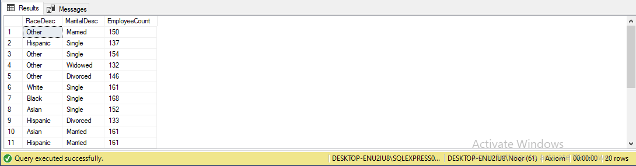GROUPBYRaceDesc, MaritalDesc

# NumberofEmployeesperSupervisor

SELECTSupervisor,COUNT(*)ASEmployeeCountFROM employee_data

GROUPBYSupervisor

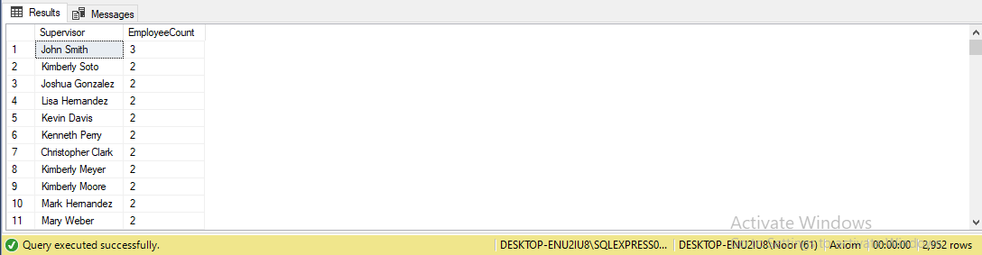ORDERBYEmployeeCountDESC

# ListofActiveEmployees

SELECTEmp**loyee_**ID,FirstName,LastName,EmployeeStatusFROM employee_data

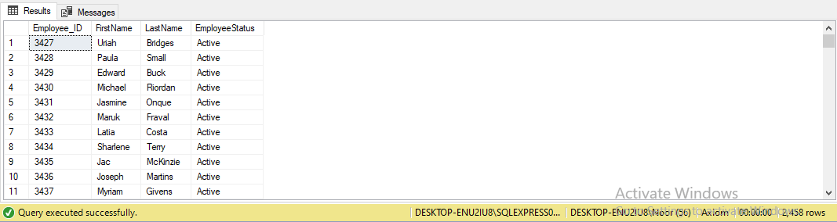WHEREEmployeeStatus='Active'

# EmployeeDemographics

SELECTGenderCode,RaceDesc,MaritalDesc,COUNT(*)ASCount FROM employee_data

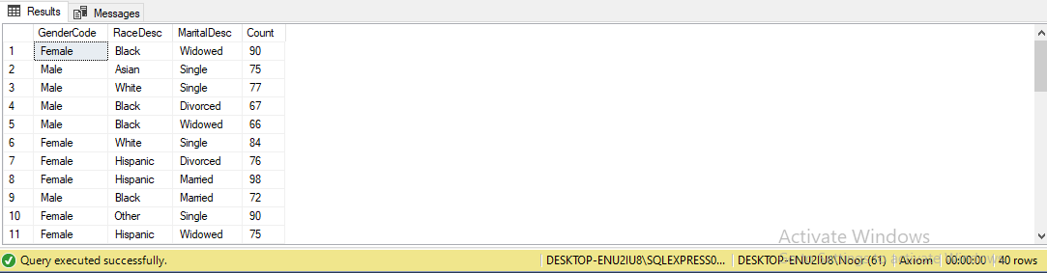GROUPBYGenderCode,RaceDesc,MaritalDesc

1. **Recruitment Status Breakdown** SELECTStatus,COUNT(*)ASCount FROM recruitment_data

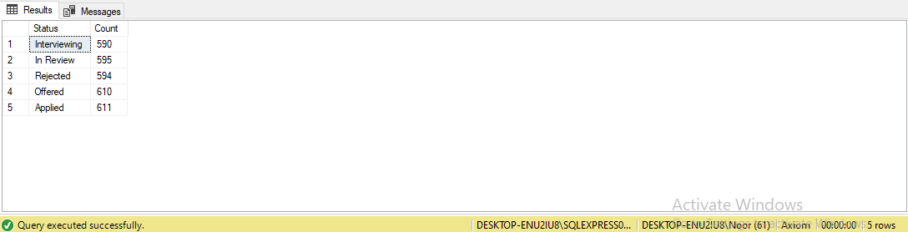GROUPBYStatus

# TrainingCostsbyProgram

SELECTTraining_Program_Name,SUM(Training_Cost)ASTotalCostFROM training_and_development_data

GROUPBYTraining_Program_Name

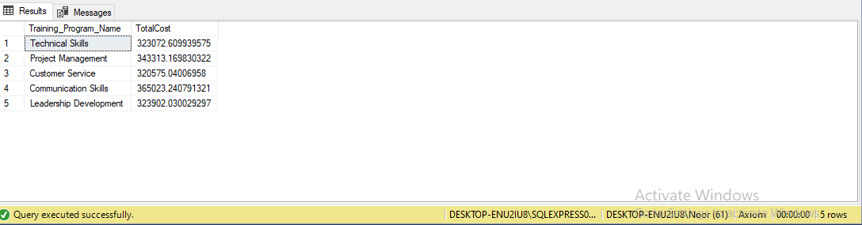

# EmployeeEngagementScores

SELECTSurvey_Date,AVG(Engagement_Score)ASAvgEngagementScoreFROM employee_engagement_survey_data

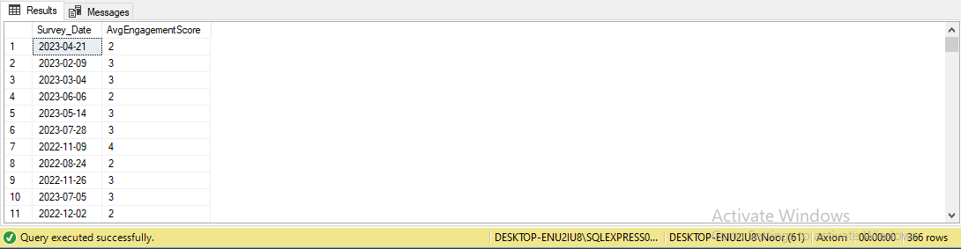GROUPBYSurvey_Date

# Highest-PaidEmployees

SELECTFirstName,LastName,PayZone,MAX(Current_Employee_Rating) AS MaxRating

FROMemployee_data

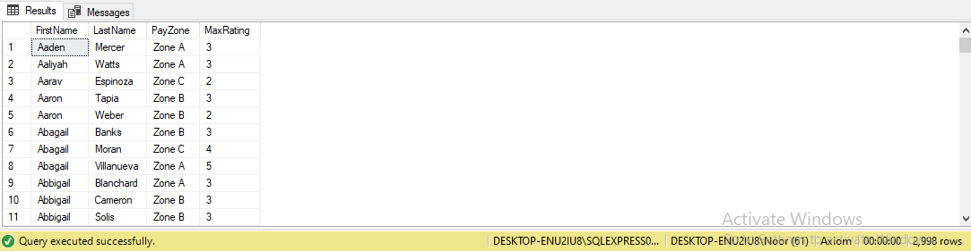GROUPBYFirstName,LastName,PayZone

# ApplicantsbyEducationLevel

SELECTEducation_Level,COUNT(*)ASCount FROM recruitment_data

GROUPBYEducation_Level

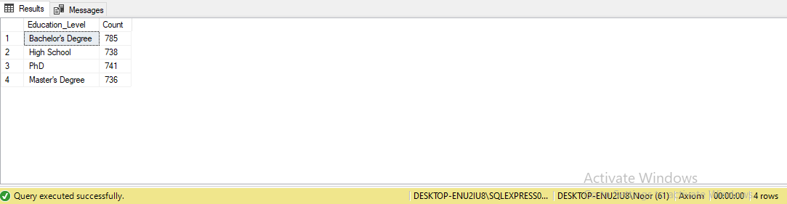

# EmployeeExit Reasons

SELECTTerminationType,COUNT(*)ASCount FROM employee_data

WHEREExitDateISNOTNULL

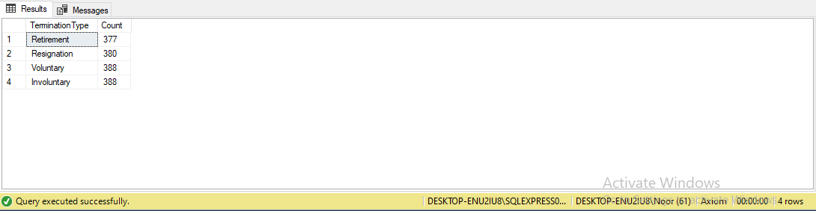GROUPBYTerminationType

# AverageDesiredSalarybyJobTitle

SELECTJob_Title,AVG(Desired_Salary)ASAvgSalaryFROM recruitment_data

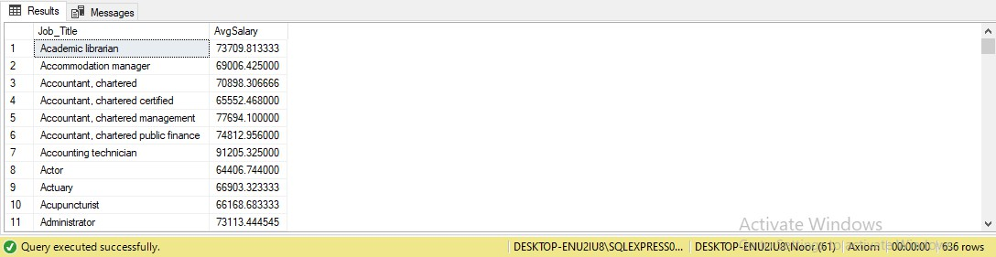GROUPBYJob_Title

# EmployeePerformance Distribution

SELECTPerformance_Score,COUNT(*)ASCount FROM employee_data

GROUPBYPerformance_Score

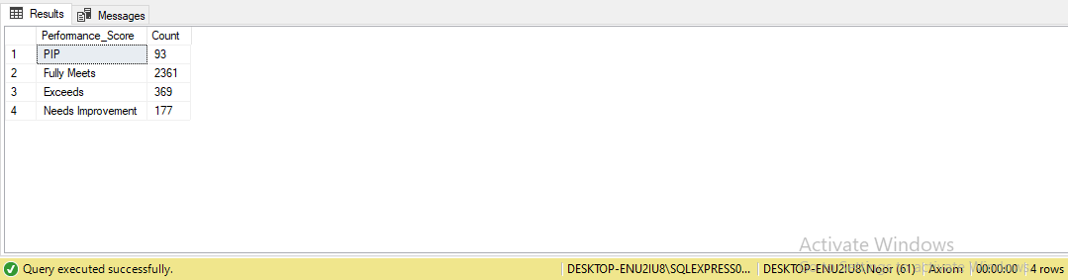

# Applicantsby Country

SELECTCountry,COUNT(*)ASCount FROM recruitment_data

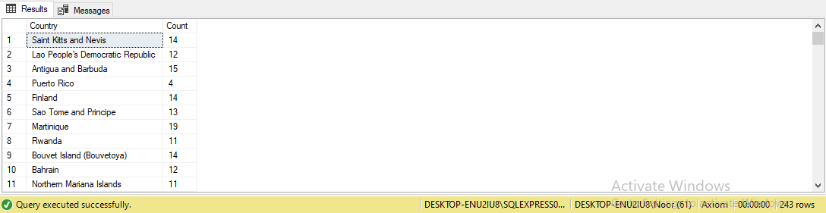GROUPBYCountry

# TrainingDurationbyType

SELECTTraining_Type,AVG(Training_Duration_Days)ASAvgDurationFROM training_and_development_data

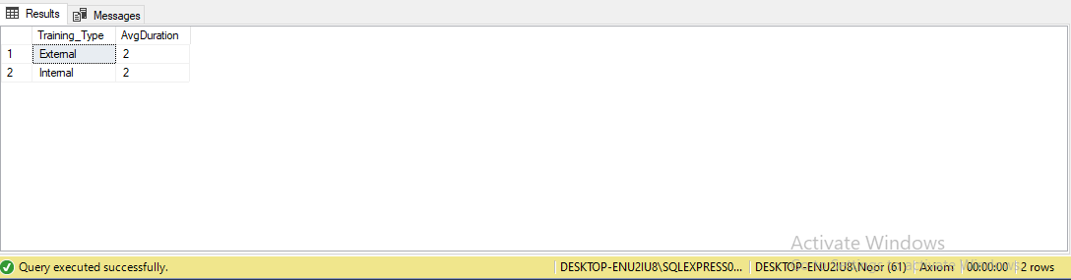GROUPBYTraining_Type

# RecruitmentbyJobTitleandGender

SELECTJob_Title,Gender,COUNT(*)ASCount FROM recruitment_data

GROUPBYJob_Title,Gender

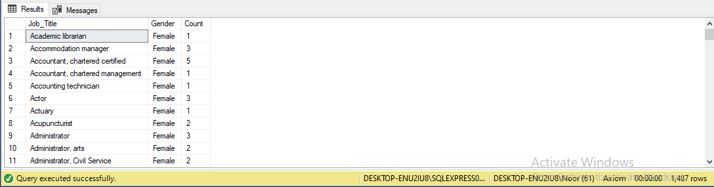

# EmployeeCountby State

SELECTState,COUNT(*)ASEmployeeCountFROM employee_data

GROUPBYState

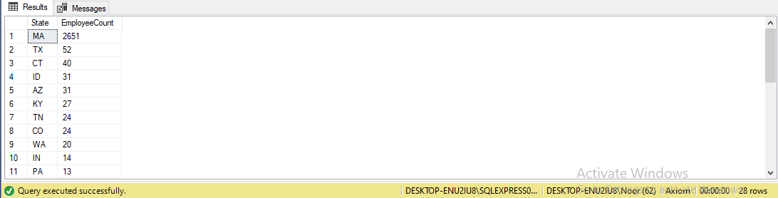ORDERBYEmployeeCountDESC

# TrainingCostsbyLocation

SELECTLocation,SUM(Training_Cost)ASTotalCostFROM training_and_development_data

GROUP BY Location ORDERBYTotalCostDESC

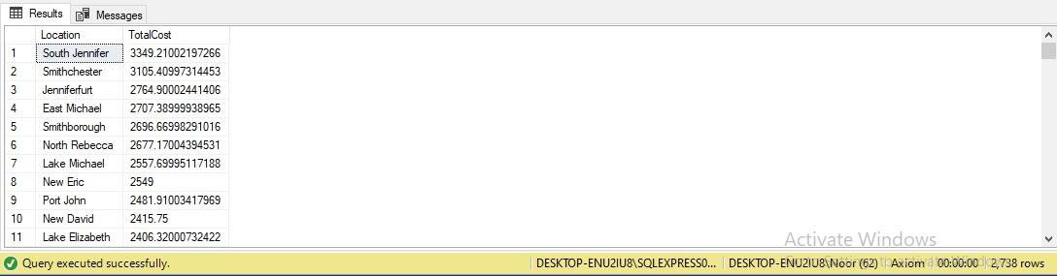

# EmployeeTurnoverbyGenderandMaritalStatus

SELECTGenderCode,MaritalDesc,COUNT(*)ASTurnoverCountFROM employee_data

WHEREExitDateISNOTNULL

GROUPBYGenderCode,MaritalDescORDER BY TurnoverCountDESC

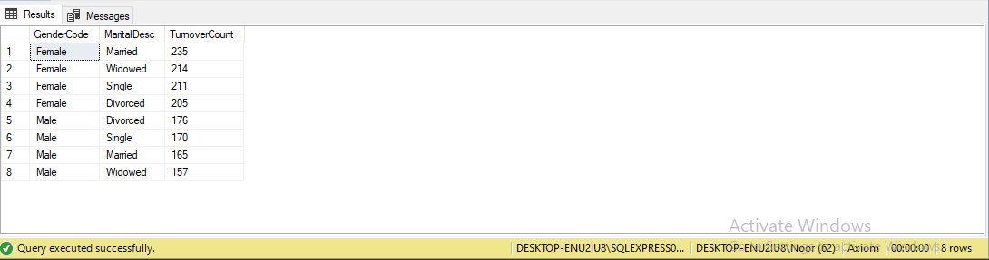

1. **Employee Demographics and Performance**SELECTGenderCode,RaceDesc,Performance_Score, AVG(Current_Employee_Rating) AS AvgRatingFROM employee_data

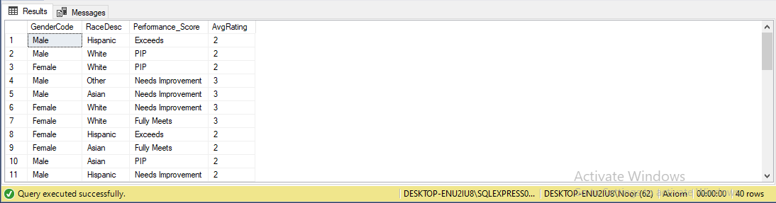GROUPBYGenderCode,RaceDesc,Performance_Score

# EmployeeExitReasonsbyDepartment

SELECTDepartmentType,TerminationType,COUNT(*)ASCount FROM employee_data

WHEREExitDateISNOTNULL

GROUPBYDepartmentType,TerminationTypeORDER BY DepartmentType, Count DESC

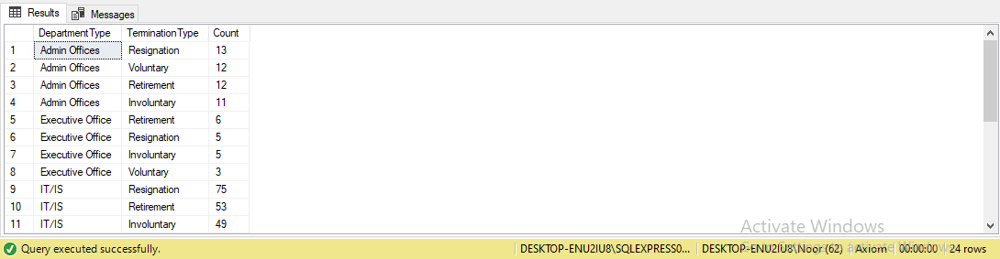

# AverageDesiredSalarybyEducation Level

SELECTEducation_Level,AVG(Desired_Salary)ASAvgSalaryFROM recruitment_data

GROUP BY Education_LevelORDERBYAvgSalaryDESC

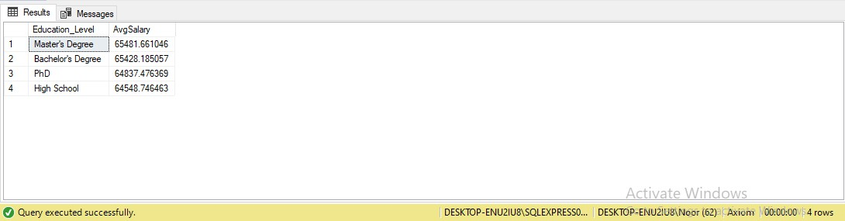

# EmployeePerformancebyGenderand Department

SELECTGenderCode,DepartmentType,AVG(Current_Employee_Rating) AS AvgRating

FROMemployee_data

GROUP BY GenderCode, DepartmentTypeORDERBYGenderCode,AvgRatingDESC

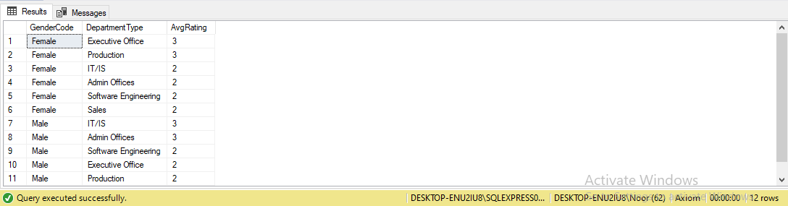

# AverageEmployeeRatingbyGenderandMaritalStatus

SELECTGenderCode,MaritalDesc,AVG(Current_Employee_Rating)AS AvgRating

FROMemployee_data

GROUPBYGenderCode,MaritalDescORDER BY AvgRatingDESC

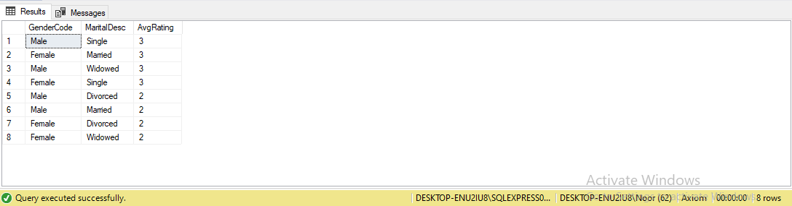

# AverageTrainingDurationbyTrainingProgramType

SELECTTraining_Program_Name,AVG(Training_Duration_Days)AS AvgDuration

FROMtraining_and_development_dataGROUP BY Training_Program_NameORDER BY AvgDurationDESC

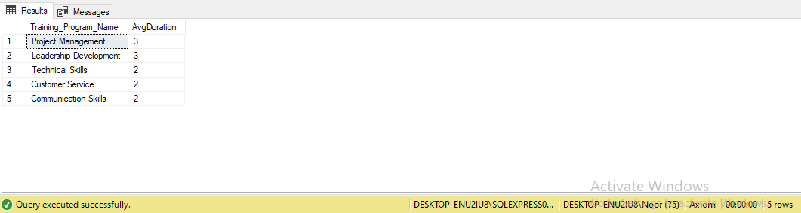

# RecruitmentbyEducationLeveland Gender

SELECTEducation_Level,Gender,COUNT(*)ASCount FROM recruitment_data

GROUP BY Education_Level, Gender ORDERBYEducation_Level,CountDESC

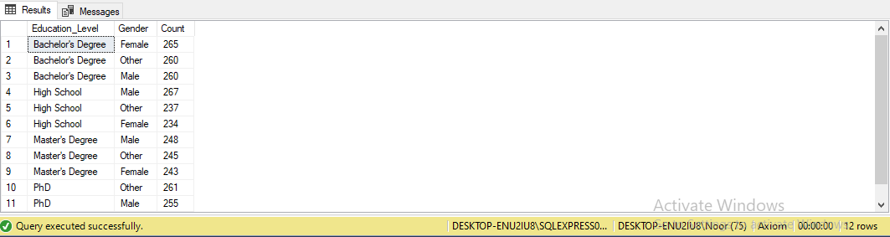

# EmployeeCountbyDepartmentandJob Title

SELECTDepartmentType,JobFunctionDescription,COUNT(*)AS EmployeeCount

FROMemployee_data

GROUPBYDepartmentType,JobFunctionDescriptionORDER BY DepartmentType, EmployeeCountDESC

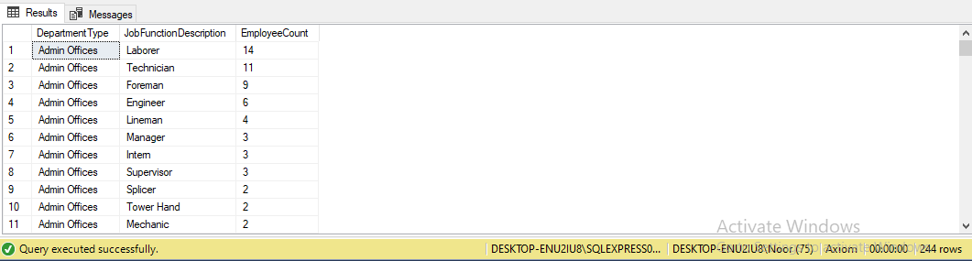

# TotalTrainingCostsbyBusinessUnit

SELECTed.BusinessUnit,SUM(tdd.Training_Cost)ASTotalCostFROM employee_data ed

JOINtraining_and_development_datatddONed.EmpID=tdd.Employee_IDGROUP BY ed.BusinessUnit

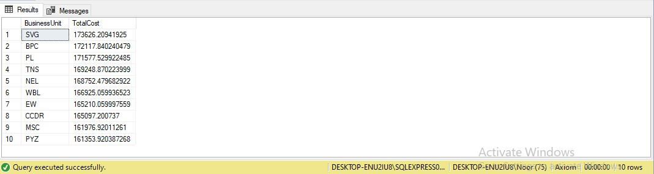ORDERBYTotalCostDESC

# EmployeeEngagement TrendsOver Time

SELECTSurvey_Date,AVG(Engagement_Score)ASAvgEngagementScoreFROM employee_engagement_survey_data

GROUPBYSurvey_DateORDER BYSurvey_Date

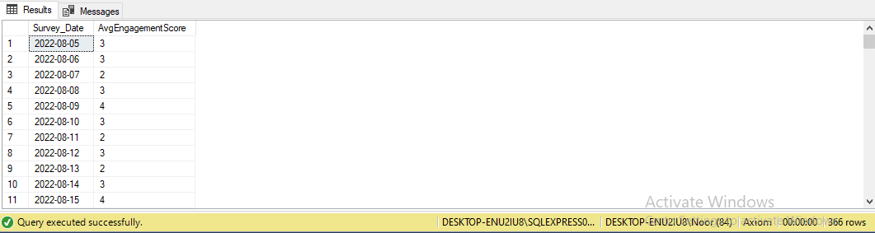

# AverageTenurebyDepartment

SELECTDepartmentType,AVG(DATEDIFF(day,StartDate,ExitDate))AS AvgTenure

FROMemployee_data

WHEREExitDateISNOTNULL

GROUP BY DepartmentTypeORDERBYAvgTenureDESC

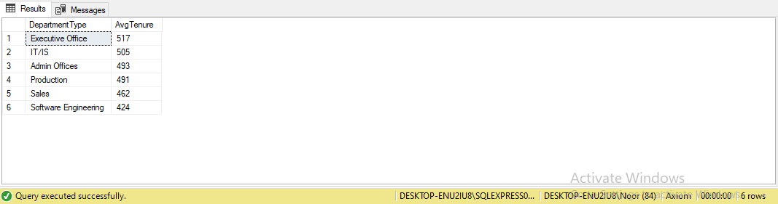

# RecruitmentbyCityand State

SELECTCity,State,COUNT(*)ASCount FROM recruitment_data

GROUP BY City, State ORDERBYCountDESC

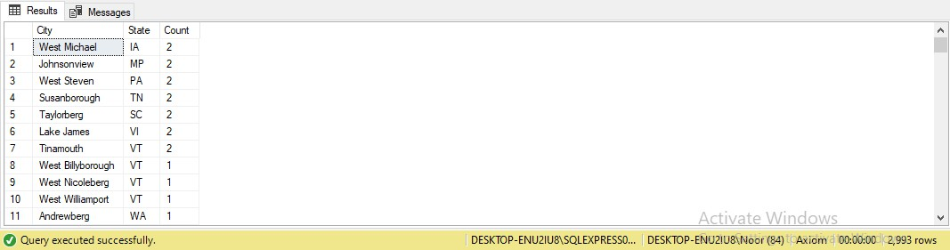

# TrainingTypeDistribution

SELECTTraining_Type,COUNT(*)ASCount FROM training_and_development_dataGROUP BY Training_Type

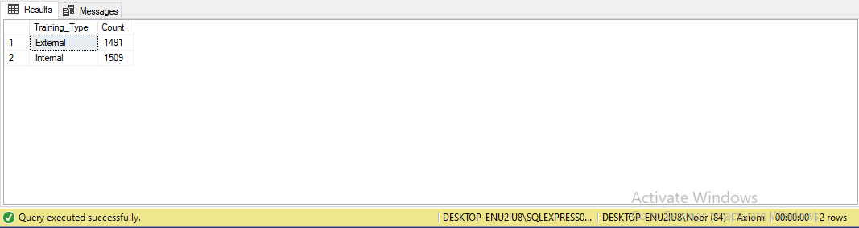

# Top-performingSupervisorsbyEmployeeRating

SELECTSupervisor,AVG(Current_Employee_Rating)ASAvgRatingFROM employee_data

GROUPBYSupervisor

HAVINGAVG(Current_Employee_Rating)>=4.0 ORDER BY AvgRatingDESC

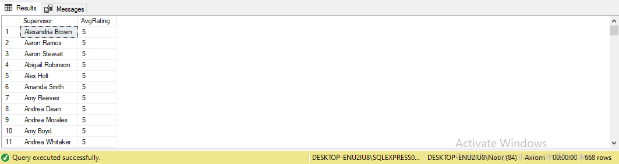

# EmployeeEngagement byLocation

SELECTe.LocationCode,AVG(ee.Engagement_Score)AS AvgEngagementScore

FROMemployee_datae

JOINemployee_engagement_survey_dataeeONe.Employee_ID= ee.Employee_ID

GROUPBYe.LocationCode

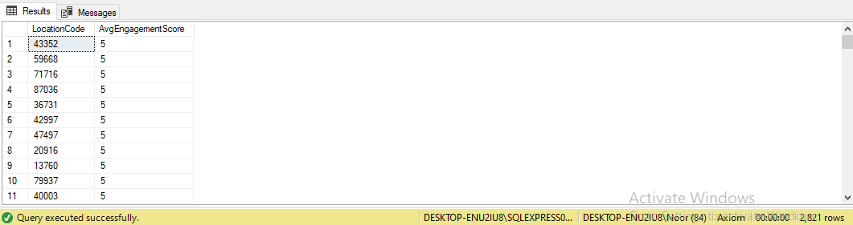ORDERBYAvgEngagementScoreDESC

1. **Training Cost per Employee by Business Unit** SELECTed.BusinessUnit,SUM(tdd.Training_Cost)/ COUNT(ed.Employee_ID) AS CostPerEmployeeFROM employee_data ed

JOINtraining_and_development_datatddONed.Employee_ID= tdd.Employee_ID

GROUP BY ed.BusinessUnitORDERBYCostPerEmployeeDESC

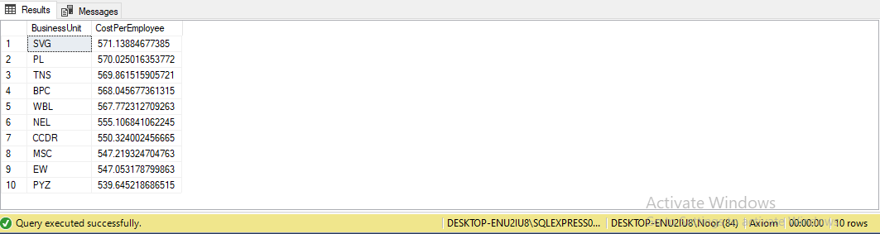

# AverageDesiredSalarybyGenderandEducationLevel

SELECTGender,Education_Level,AVG(Desired_Salary)ASAvgSalaryFROM recruitment_data

GROUPBYGender,Education_LevelORDER BY AvgSalaryDESC

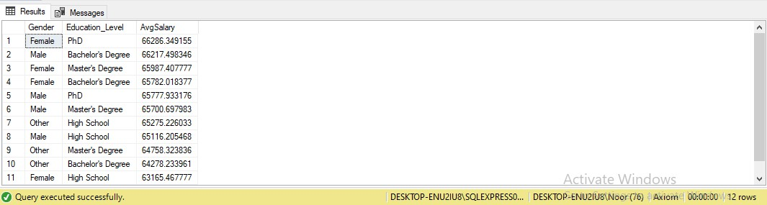

# EmployeesandTheirTrainingPrograms

SELECTed.FirstName,ed.LastName,tdd.Training_Program_NameFROM employee_data ed

JOINtraining_and_development_datatddONed.Employee_ID= tdd.Employee_ID

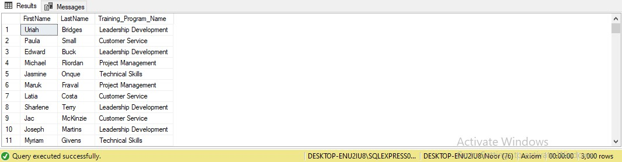WHEREtdd.Training_Program_NameISNOTNULL

1. **RecruitmentStatusandDesiredSalarybyJobTitle** SELECT rd.Job_Title, rd.Status, rd.Desired_SalaryFROM recruitment_datard

WHERErd.Status='Offered'ANDrd.Desired_Salary>=60000

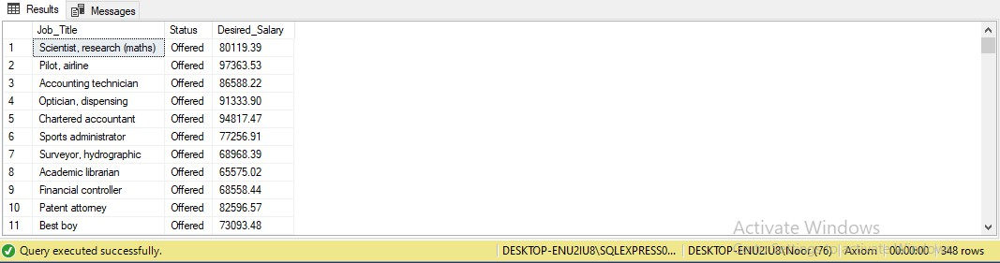

# EmployeeswithHighEngagementScores

SELECTed.FirstName,ed.LastName,ed.EmployeeStatus, ees.Engagement_Score

FROMemployee_dataed

JOINemployee_engagement_survey_dataeesONed.Employee_ID= ees.Employee_ID

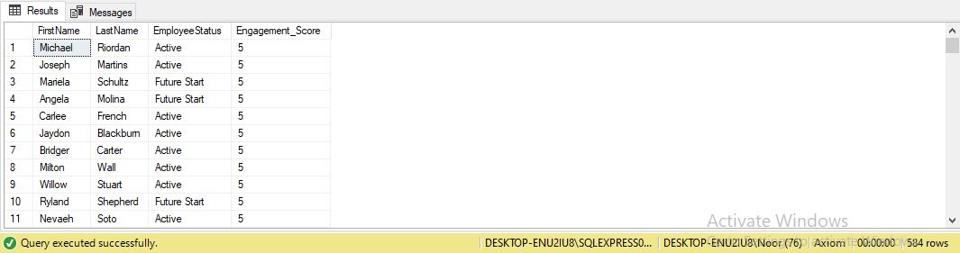WHEREees.Engagement_Score>=4.5

# EmployeesandTheirTrainingCosts

SELECTed.FirstName,ed.LastName,tdd.Training_CostFROM employee_data ed

JOINtraining_and_development_datatddONed.Employee_ID= tdd.Employee_ID

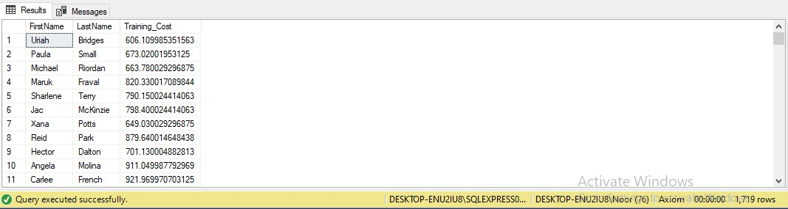WHEREtdd.Training_Cost>500

1. **Recruitment by State and Highest Education Level** SELECTrd.State,rd.Education_Level,COUNT(*)ASCount FROM recruitment_datard

WHERE rd.Education_Level= 'PhD' GROUPBYrd.State,rd.Education_LevelORDER BY State, Count DESC

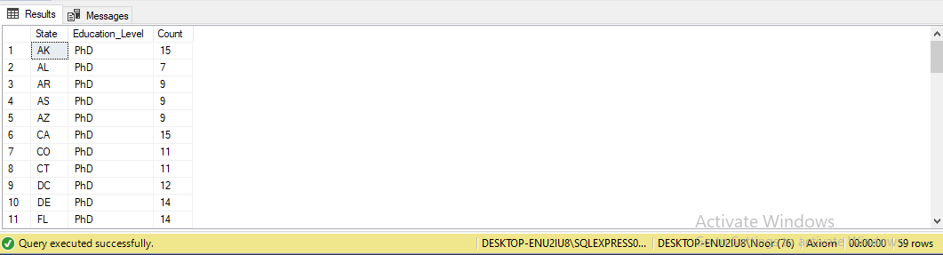

# TrainingCostsbyTrainingTypeandSpecificLocation

SELECTtdd.Training_Type,tdd.Location,SUM(tdd.Training_Cost)AS TotalCost

FROMtraining_and_development_datatddWHERE tdd.Location= 'Lake Tony'

GROUPBYtdd.Training_Type,tdd.LocationORDER BY TotalCostDESC

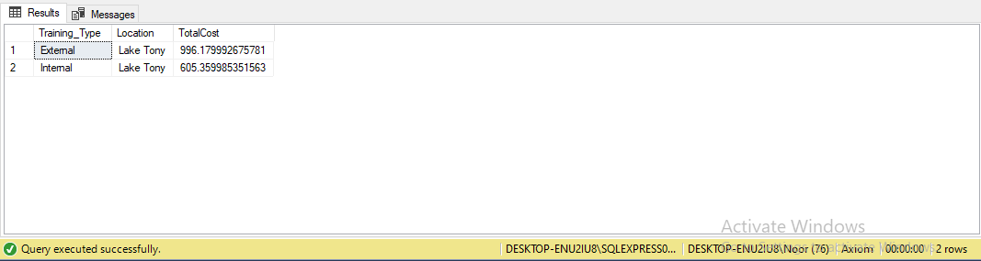

1. **EmployeePerformancebyJobTitleandTrainingType** SELECT ed.JobFunctionDescription, tdd.Training_Type, AVG(ed.Current_Employee_Rating) AS AvgRatingFROM employee_data ed

JOINtraining_and_development_datatddONed.Employee_ID= tdd.Employee_ID

GROUPBYed.JobFunctionDescription,tdd.Training_TypeORDER BY AvgRatingDESC

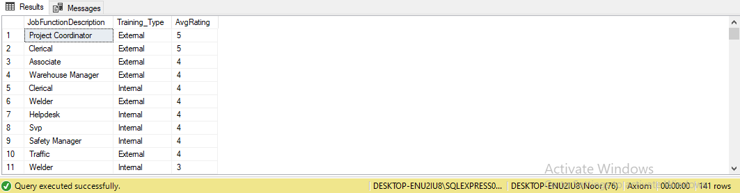

# TrainingProgramsbyEmployeeandLocation

SELECTed.FirstName,ed.LastName,tdd.Training_Program_Name, tdd.Location

FROMemployee_dataed

JOINtraining_and_development_datatddONed.Employee_ID= tdd.Employee_ID

WHEREtdd.Training_Program_NameISNOTNULLANDtdd.LocationIS NOT NULL

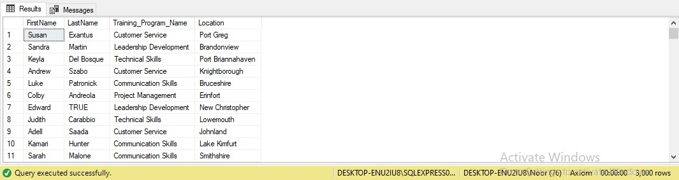

# EmployeeTenureDistributionbyBusinessUnit

SELECTBusinessUnit,AVG(DATEDIFF(day,StartDate,ExitDate))AS AvgTenureDays

FROMemployee_data

WHEREExitDateISNOTNULL

GROUPBYBusinessUnit

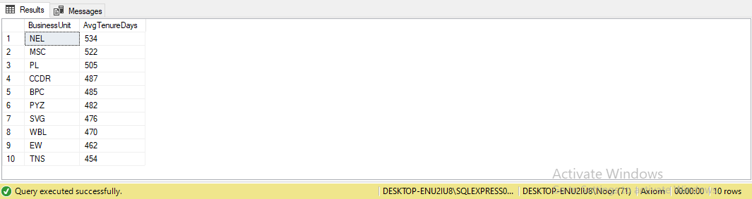ORDERBYAvgTenureDaysDESC

# EmployeePromotionAnalysis

SELECTPerformance_Score,COUNT(*)ASPromotionCountFROM employee_data

WHEREEmployeeStatus='Active'ANDEmployeeType='Full-Time' GROUP BY Performance_Score

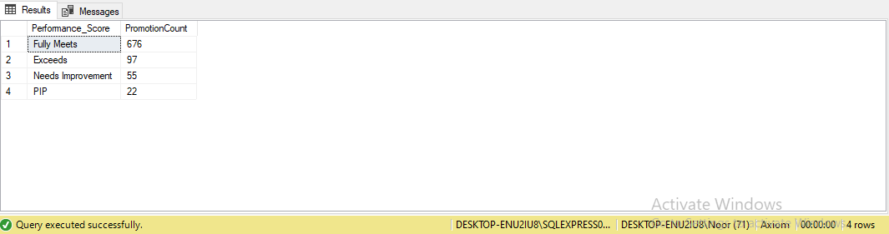ORDERBYPromotionCountDESC

# EmployeeEngagementTrendbyDepartment

SELECTee.Survey_Date,ed.DepartmentType,AVG(ee.Engagement_Score) AS AvgEngagementScore

FROMemployee_dataed

JOINemployee_engagement_survey_dataeeONed.Employee_ID= ee.Employee_ID

GROUPBYee.Survey_Date,ed.DepartmentTypeORDER BY ee.Survey_Date

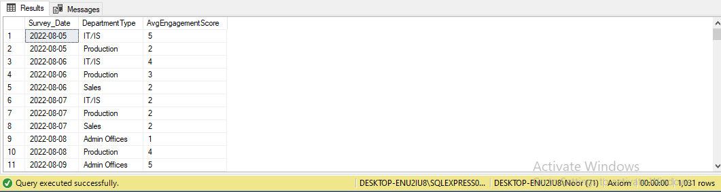

# RecruitmentCostAnalysis

SELECT rd.Education_Level, COUNT(*) AS Applicants, SUM(Desired_Salary)ASTotalDesiredSalary,SUM(Desired_Salary)/ COUNT(*) AS AvgSalaryPerApplicant

FROM recruitment_datardGROUPBYrd.Education_Level

ORDERBYAvgSalaryPerApplicantDESC

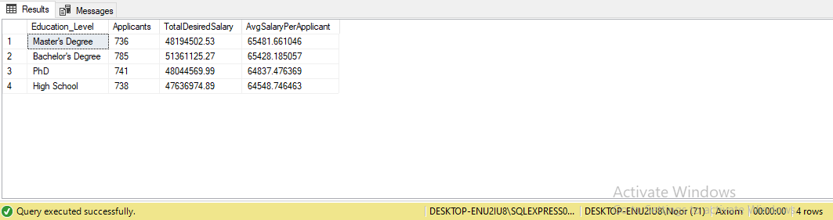

# EmployeeExitPatternsbyTenure

SELECTTerminationType,AVG(DATEDIFF(day,StartDate,ExitDate))AS AvgTenureDays

FROMemployee_data

WHEREExitDateISNOTNULL

GROUP BY TerminationTypeORDERBYAvgTenureDaysDESC

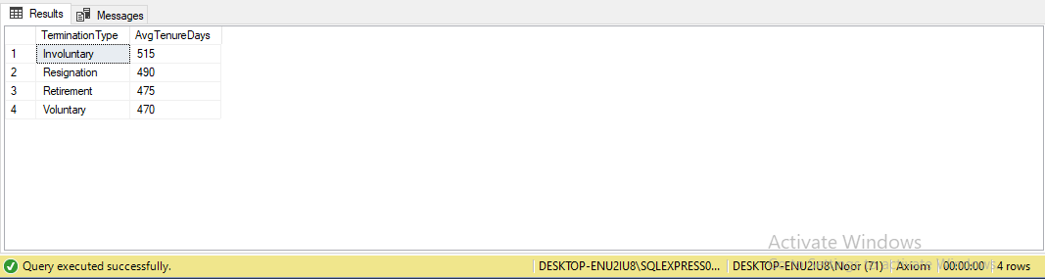

1. **EmployeeEngagementandPerformanceCorrelationOverTime** WITH EngagementPerformanceAS (SELECT e.Employee_ID, e.Survey_Date, e.Engagement_Score, ed.Current_Employee_RatingFROM employee_engagement_survey_data e

JOINemployee_dataedONe.Employee_ID=ed.Employee_IDWHERE ed.EmployeeStatus= 'Active')

SELECTSurvey_Date,AVG(Engagement_Score)ASAvgEngagementScore, AVG(Current_Employee_Rating) AS AvgPerformanceRating

FROMEngagementPerformanceGROUP BY Survey_DateORDER BY Survey_Date

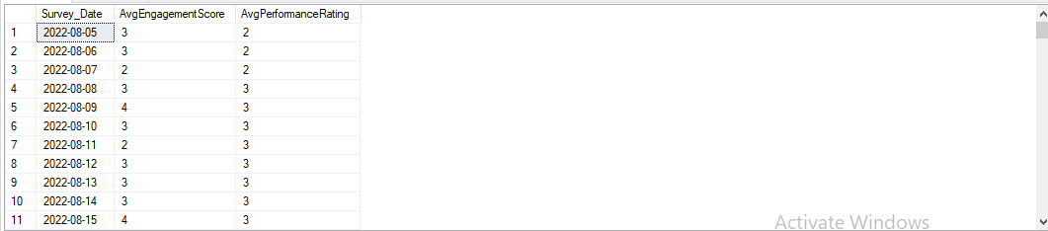

# DATAANALYSISSUMMARY

The provided SQL queries encompass a wide range of HR-related data analyses, sheddinglightonvariousaspectsofanorganization'sworkforce.Thesequeriesallow HR professionals and decision-makers to gain valuable insights into employee demographics, engagement, performance, recruitment, training, turnover, and more. Below is a summary of the key findings and insights derived from these queries:

# EmployeeDemographicsandDistribution

The organization's workforce is divided into different business units, and the employeecountvariesacrosstheseunits.Demographicssuchasgender,race,and marital status have been analyzed to provide a comprehensive view of the workforce's diversity.

# EmployeeEngagementandPerformance

Employee engagement scores have been tracked over time, showing trends in employeesatisfaction.Theanalysisofperformancescoresbygender,department, and job title allows for a deeper understanding of performance trends within the organization.

# RecruitmentandApplicantAnalysis

Recruitmentdataincludesinformationonapplicants'educationlevels,desired salaries, and statuses. The analysis provides insights into the educational qualifications and salary expectations of job applicants.

# TrainingandDevelopment

Trainingprogramshavebeencategorizedbytype,andthecostsassociated with eachprogramhavebeencalculated.Trainingdurationandcostsareanalyzedby program, location, and business unit.

# EmployeeTurnoverandExitPatterns

Employee turnover has been examined by gender, marital status, tenure, and department.Exitreasonshavebeencategorizedtoidentifycommonreasonsfor employee departures.

# PerformanceandPromotion

Employeeperformancescoreshavebeenanalyzed,andthenumberofpromotions for active, full-time employees has been determined. This analysis helps in understanding the relationship between performance and promotions.

# GeographicAnalysis

Employeecountsandrecruitmentdatahavebeenbrokendownbystate,city,and country. Training costs and employee tenure are also analyzed by location.

# Supervisorand Leadership

Theanalysisidentifiestop-performingsupervisorsbasedonemployeeratings, potentially highlighting effective leadership.

# CostAnalysis

Various cost-related analyses have been performed, including training costs by program,businessunit,andlocation.Recruitmentcostshavealsobeenanalyzed in terms of desired salary expectations.

# EngagementandPerformanceCorrelation

Acorrelationbetweenemployeeengagementscoresandperformanceratingsover time has been established.

In summary, these SQL queries enable HR professionals to make data-driven decisions, optimize workforce management, enhance employee engagement and performance,andaddressrecruitmentandtrainingneedseffectively.Theinsights gained from these analyses can inform HR strategies, improve organizational efficiency, and contribute to a more engaged and productive workforce.

# SUMMARYOFHRDECISION-MAKINGINSIGHTS

The extensive analysis of HR data through 50 SQLqueries has yielded valuable insightsthatcansignificantlyimpactHRdecision-makingprocesses.Theseinsights span various facets of human resources, offering actionable knowledge to enhance workforcemanagement,recruitmentstrategies,traininganddevelopmentprograms, employee engagement initiatives, and overall organizational performance. Here are the key decision-making insights derived from the analysis:

# WorkforceManagement

1. EmployeeDemographics:Understandingthedemographiccompositionofthe workforce is crucial for fostering diversity and inclusion efforts, addressing disparities, and tailoring HR policies to specific groups.
2. EmployeePerformanceDistribution:Identifyingperformancescore distributions allow HR to recognize top performers, address underperformance, and implement targeted improvement plans.
3. EmployeePromotionAnalysis:Recognizinghigh-performingemployeesfor potential promotions can boost morale and retain talent.
4. EmployeeExitPatternsbyTenure:Recognizingpatternsinemployeeexits concerning tenure can help in designing retention strategies and reducing turnover.
5. AverageTenurebyDepartment:Knowingtheaveragetenurebydepartment can inform succession planning and workforce stability.
6. Highest-PaidEmployees:Identifyinghighperformerswhoarealsowell- compensated can help in retaining and incentivizing top talent.
7. Employee Engagement and Performance Correlation Over Time: Understandingtherelationshipbetweenengagementandperformancescores over time can help HR tailor engagement strategies to boost performance.

# RecruitmentStrategies

1. ApplicantsbyEducationLevel:Insightintotheeducationalbackgroundof applicants assists in tailoring job requirements and recruitment strategies.
2. RecruitmentbyJobTitleandGender:Identifyinggenderdisparitiesinjob applicationshighlightspotential areas forgender diversity improvements.
3. RecruitmentbyCityandState:Understandinggeographicalpatternsin recruitment aids in targeting specific regions for talent acquisition.
4. RecruitmentCostAnalysis:Analyzingrecruitmentcostsanddesiredsalaries by education level can optimize recruitment budgets and compensation packages.

# TrainingandDevelopment

1. TrainingCostsbyProgram:Identifyingthecostofdifferenttrainingprograms enables efficient allocation of resources.
2. TrainingDurationbyType:Knowingthedurationofvarioustraining programs helps in scheduling and planning employee development.
3. TrainingCostsbyLocation:Understandingtrainingcostsbylocationcanaid in optimizing training budgets and selecting cost-effective venues.

# EmployeeEngagement

1. EmployeeEngagementScores:Monitoringengagementscoresovertime provides insights into employee satisfaction and morale.
2. Employees with High Engagement Scores: Recognizing highly engaged employeescanserveasanexampleofbestpracticesandinformengagement strategies for others.
3. EmployeeEngagementTrendsOverTime:Trackingengagementtrendshelps HR assess the effectiveness of engagement initiatives and adapt strategies as needed.

# Cross-FunctionalInsights

1. Employee Engagement and Performance Correlation Over Time: The correlationbetween engagementandperformance scoreshighlightsthe importanceofengagementinitiativesinenhancingproductivityandjob satisfaction.

These insights underscore the significance of data-driven decision-making in HR. By leveragingthefindingsfromtheseSQLqueries,HRprofessionalscanmakeinformed choices to optimize workforce management, improve recruitment processes, refine training programs, boost employee engagement, and ultimately contribute to the overall success of the organization. These insights also emphasize the value of regularly monitoring and analyzing HR data to adapt to changing workforce dynamics and continually improve HR strategies and practices.